LOCAL AREA NETWORK (LAN)

AN INNOVATION PROJECT FOR KALOLENI LAW COURT



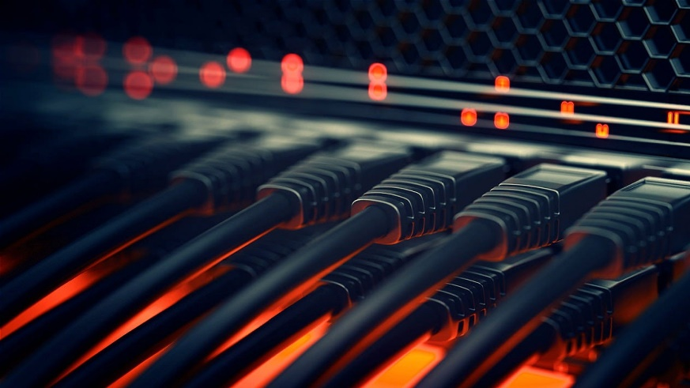

Background of the Problem

This innovation project was started so as to improve working conditions by mitigating specific problems experienced at Kaloleni Law Court. These problems include:

1. Shortage of Computers: There being a total of 4 computers at the registry to be shared amongst 12 staff members, completing daily duties is difficult especially when one has urgent matters to attend to.
2. Resource Sharing: In most working environments, the resources shared include printers and scanners, but this project focused more on sharing files and documents from one computer to another so as to allow people to work from any computer in the registry.
3. Lack of Backups: There being a lot of sensitive data on these computers, it is recommended to have online backups for casual documents while maintaining local backups for sensitive data.

What is a Local Area Network?

A Local Area Network, or LAN for short, is a computer network that connects devices within a limited area such as a home, office, or a small group of buildings. LANs are commonly used to share resources such as printers, files, and applications among connected devices.

LANs typically use Ethernet cables or Wi-Fi to connect devices such as computers, printers, and servers. The network is managed by a central device called a switch or hub. This device acts as a communication point between devices and helps to manage the flow of data on the network.

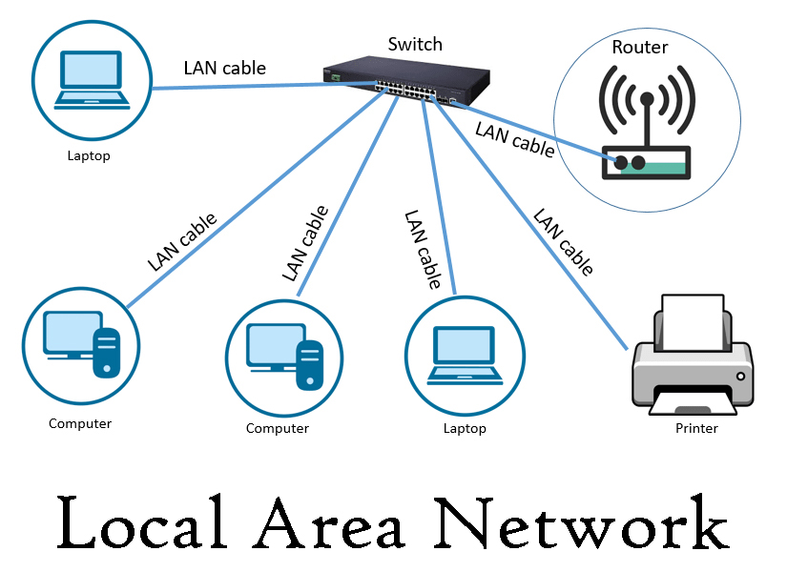

Local Area Network Image

Advantages of using LAN

There are several advantages of using a LAN, including:

1. Resource sharing: LANs allow devices such as printers, scanners, and documents to be shared among connected devices, reducing the need for each device to have its own dedicated resource.
2. Cost-effective: By eliminating the need for multiple devices, such as printers, setting up a Local Area Network is pocket friendly.
3. High-Speed Communication: LANs offer faster data transfer speeds due to the direct connectivity between computers
4. Centralized data management: This makes it easier to backup data, monitor network activity, and implement data security measures.
5. Flexible Work Environment: Personnel are able to share and work on documents saved in different computers in real-time.

Disadvantages of using LAN

Limited coverage area: A LAN is limited to a small geographical area

Dependence on central device: Devices such as a router or switch are crucial to the network. If this device fails, the entire network may be affected, leading to downtime and loss of productivity.

Complexity: Setting up and managing a LAN can be complex and require technical expertise, particularly for larger networks.

Security vulnerabilities: Despite being more secure than wide area networks, LANs are still vulnerable to cyber-attacks and other security threats. If not properly secured, a LAN can be compromised, leading to data theft, malware infections, and other security breaches.

How to set up LAN in windows

Setting up a LAN in Windows involves several steps:

1. Connect the computers: Connect the computers to the same network. This can be done using Ethernet cables, a wireless router, or a switch.

2. Configure network settings: On each computer, go to the Control Panel and select Network and Sharing Center. From there, select Change adapter settings and right-click on the Ethernet or Wi-Fi connection that you are using to connect to the LAN. Select Properties and make sure that the settings are configured for automatic IP address assignment (DHCP).

3. Set up a network name: On one of the computers, go to Control Panel and select Network and Sharing Center. From there, select Set up a new connection or network and follow the prompts to set up a network name and select the type of network you want to create (work or home).

4. Share resources: On each computer, select the files or printers that you want to share. Right-click on the file or printer and select Properties. From there, select the Sharing tab and select the option to share the resource.

5. Access shared resources: On each computer, you should now be able to access the shared resources from other computers on the LAN. To do this, go to File Explorer and select Network. You should see the other computers and shared resources on the LAN.

By following these steps, you can set up a LAN in Windows and share resources among multiple computers on the network.

Why use LAN over WLAN

While both LANs and WLANs offer benefits, there are several reasons why someone might choose to use a LAN over a WLAN:

1. Security: LANs are generally considered more secure than WLANs because they are more difficult to hack into. This is because WLANs use wireless signals that can be intercepted by unauthorized individuals.
2. Speed: LANs offer faster data transfer speeds than WLANs. This is because wired connections are generally faster and more reliable than wireless connections.
3. Reliability: Wired LAN connections are generally more reliable than wireless connections. This is because wireless signals can be disrupted by interference from other devices, distance, or physical barriers such as walls.
4. Cost: While WLANs are generally less expensive to set up initially, wired LANs are typically less expensive to maintain over time. This is because wireless networks require ongoing maintenance, including monitoring for signal interference and ensuring that security protocols are up-to-date.
5. Ease of use: While WLANs can be convenient because they do not require wires or cables, setting them up can be more complex than setting up a LAN.

Overall, while WLANs can be useful in certain situations, wired LANs are generally considered more secure, reliable, and cost-effective over the long-term.

To share a folder in a LAN on Windows, you can follow these steps:

1. Right-click on the folder you want to share and select "Properties".
2. In the "Properties" window, click on the "Sharing" tab.
3. Click on the "Advanced Sharing" button.
4. Check the box next to "Share this folder".
5. Type a name for the shared folder in the "Share name" field.
6. Configure the permissions for the shared folder by clicking on the "Permissions" button. Here, you can choose who can access the folder and what they can do with it (e.g. read-only or read-write access).
7. Click "OK" to save the sharing settings and close the "Properties" window.

Once you have shared the folder, other computers on the LAN should be able to access it. To access the shared folder from another computer, you can navigate to the shared folder in File Explorer or Windows Explorer by entering the network path (e.g. \computername\sharedfolder) in the address bar. You may be prompted to enter a username and password to access the shared folder, depending on the sharing settings you configured.

Any other important information about LAN?

Here are a few additional pieces of information that may be helpful when setting up or working with a LAN:

1. Network Topology: LANs can be set up using a variety of different network topologies, such as bus, star, ring, or mesh. The choice of topology can depend on factors such as the number of devices on the network, the physical layout of the network, and the desired level of redundancy.
2. Network Devices: In addition to computers, LANs may also use other network devices such as switches, routers, hubs, and access points. These devices help to manage traffic on the network, route data between different subnets, and provide wireless connectivity.
3. Network Protocols: LANs use a variety of network protocols to ensure that data is transmitted and received correctly. Some commonly used LAN protocols include Ethernet, TCP/IP, and UDP. It is important to configure these protocols correctly to ensure that data is transmitted efficiently and securely.
4. Network Security: LANs can be vulnerable to security threats such as viruses, malware, and unauthorized access. It is important to implement strong security measures such as firewalls, antivirus software, and access controls to protect the network and its data.
5. Network Monitoring: Monitoring the performance of a LAN can help to identify and troubleshoot problems before they become major issues. Network monitoring tools can help to track bandwidth usage, detect network failures, and diagnose performance issues.

Overall, understanding these aspects of LANs can help you to set up and manage a network that is reliable, efficient, and secure.

Summary presentation of all of the above

Sure! Here's a summary presentation of the information we covered:

* LAN stands for Local Area Network and is a network that connects computers and other devices within a limited area, such as a home or office.
* Some advantages of LANs include faster data transfer speeds, better security, and easier resource sharing.
* Some disadvantages of LANs include the need for physical cabling and potential scalability issues.
* LANs can be set up on Windows by connecting computers, configuring network settings, setting up a network name, and sharing resources.
* To share a folder on a LAN on Windows, you can right-click on the folder, select "Properties," click on the "Sharing" tab, and configure the sharing settings.
* Other important information to consider when working with LANs includes network topology, network devices, network protocols, network security, and network monitoring.

By understanding these aspects of LANs, you can set up and manage a network that meets your needs for speed, security, and reliability.

Top of Form

Bottom of Form